**ONLINE STORE (**E-COMMERCE**)**

**T. TARUN KUMAR**

**ABSTRACT**

The demand for efficient web design methods that may improve user experience and conversion rates for online store websites has increased due to the rapid rise of e-commerce. The important factors and best practices for creating an appealing and user-friendly online store are presented in this abstract in detail.

It's crucial to comprehend the target audience's preferences. Designers can produce a visually beautiful and pertinent website that appeals to potential clients by researching user demographics, behavior patterns, and market trends. To make sure that products and information are accessible, a user-friendly site layout and clear navigation should be given priority. In a time when customers view websites using a variety of devices and screen sizes, responsive design is essential. The user experience is improved overall and seamless browsing is ensured by optimizing the online store for mobile devices. Additionally, for reducing customer annoyance and increasing conversion rates, website speed optimization is essential. This includes quick loading times and simplified checkout procedures. Websites for online stores need to have a thorough awareness of their target market, as well as responsive and mobile-friendly layouts, persuading design elements, secure payment methods, and ongoing optimization based on data-driven insights. Online store owners may improve user experience, boost conversion rates, and ultimately fuel business growth by implementing these methods in the cutthroat e-commerce environment.

**OBJECTIVE**

The goal of web design for an online business is to develop a captivating, intuitive, and aesthetically pleasing website that successfully shows goods or services and improves the user experience as a whole. The following succinct statement sums up the main goals:

1. Enhance User Experience.
2. Increase Conversion Rates.
3. Showcase Products or Services.
4. Optimize For Mobile Device.
5. Foster Brand Consistency.
6. Enabling Scalability and Flexibility.

By focusing on these Objectives, I am going to create an online store website that engages users, drives conversions, build trust and ultimately contributes to the success of the e-commerce business.

**MODULES**

For an online store web design, several modules are typically involved to provide essential features and functionality. Here are some common modules you may find in an online store application:

**HOME PAGE MODULE:**

The homepage, also known as the main page or landing page, is the initial or default web page that users see when they visit a website. It’s important to note that homepage design can vary significantly depending on the type of website (e.g., e-commerce)

**ABOUT US MODULE:**

It gives the detailed information about the REACHSKY WEBPAGE including its turn over throughout the year, ratings, customer reviews and their achievements.

**CONTACT US MODULE:**

This module directly enables the user to contact customer service management for any queries and feedback with the given contact numbers or any mail provided by the website.

**ACCOUNT MODULE:**

The account module on a webpage typically refers to the functionality and features related to user accounts and authentication

1. User Registration

2. User Login

3. User Profile

**OFFERS MODULE:**

The offers module on a shopping webpage typically refers to the section or functionality that displays and manages promotional offers, discounts, and deals for customers. It is designed to attract users and encourage them to make purchases by providing them with special incentives or savings opportunities.

**SEARCH BAR MODULE:**

A search bar is a common feature found on many webpages, allowing users to search for specific content or information within the website or web application. It provides a convenient way for users to find relevant content quickly and efficiently.

**PROFILE:**

A profile, in the context of a webpage or application, usually refers to a user's personal account or individual representation within the system. It is a section where users can view and manage their personal information, preferences, settings, and activity.

**CART MODULE:**

All the items selected by the user to order are stored in the cart page. After Successful selection of the items, the user can go to the cart page and can check out with their order.

**SHOP NOW MODULE:**

The "Shop Now" feature on a webpage is typically a call-to-action button or link that encourages users to visit an store or start the shopping process.

**MODULE HIERARCHY**

****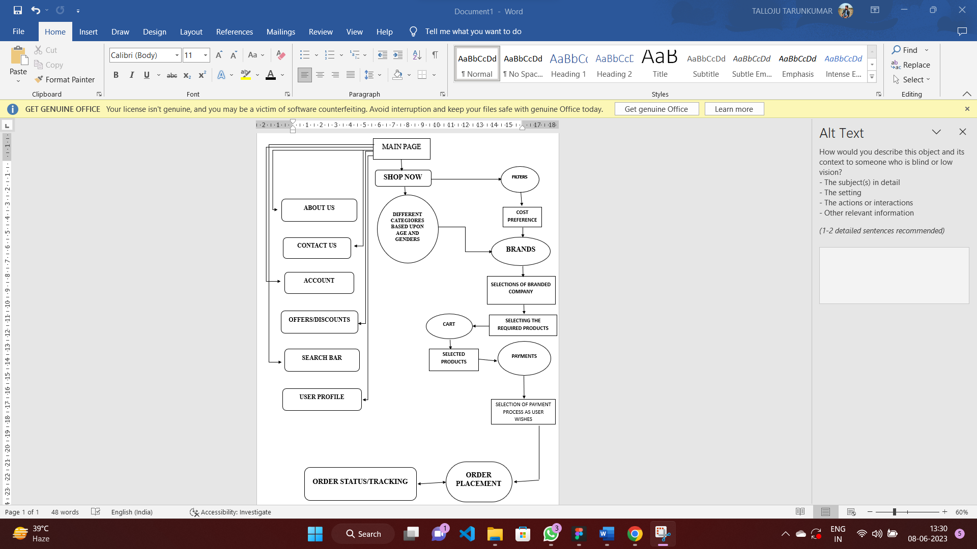

**OUTLINING SCREENS**

******